38.61: a) 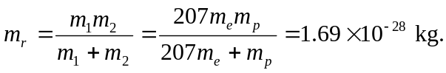
b) The new energy levels are given by Eq. (38.18) with 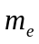 replaced by 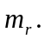
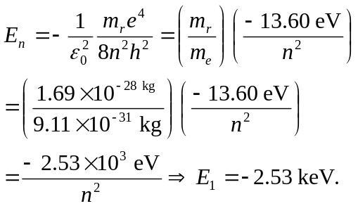
c)
